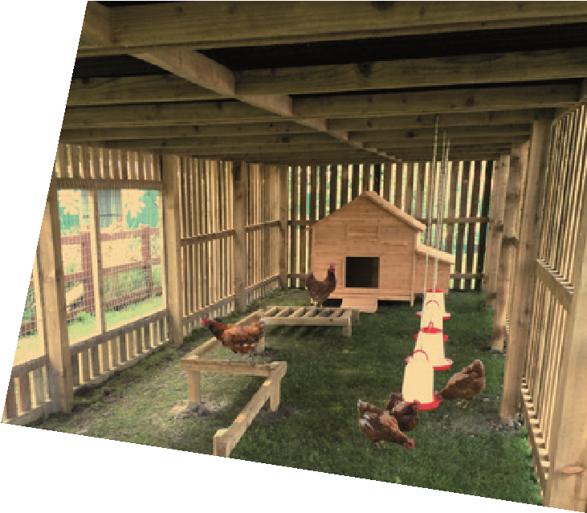
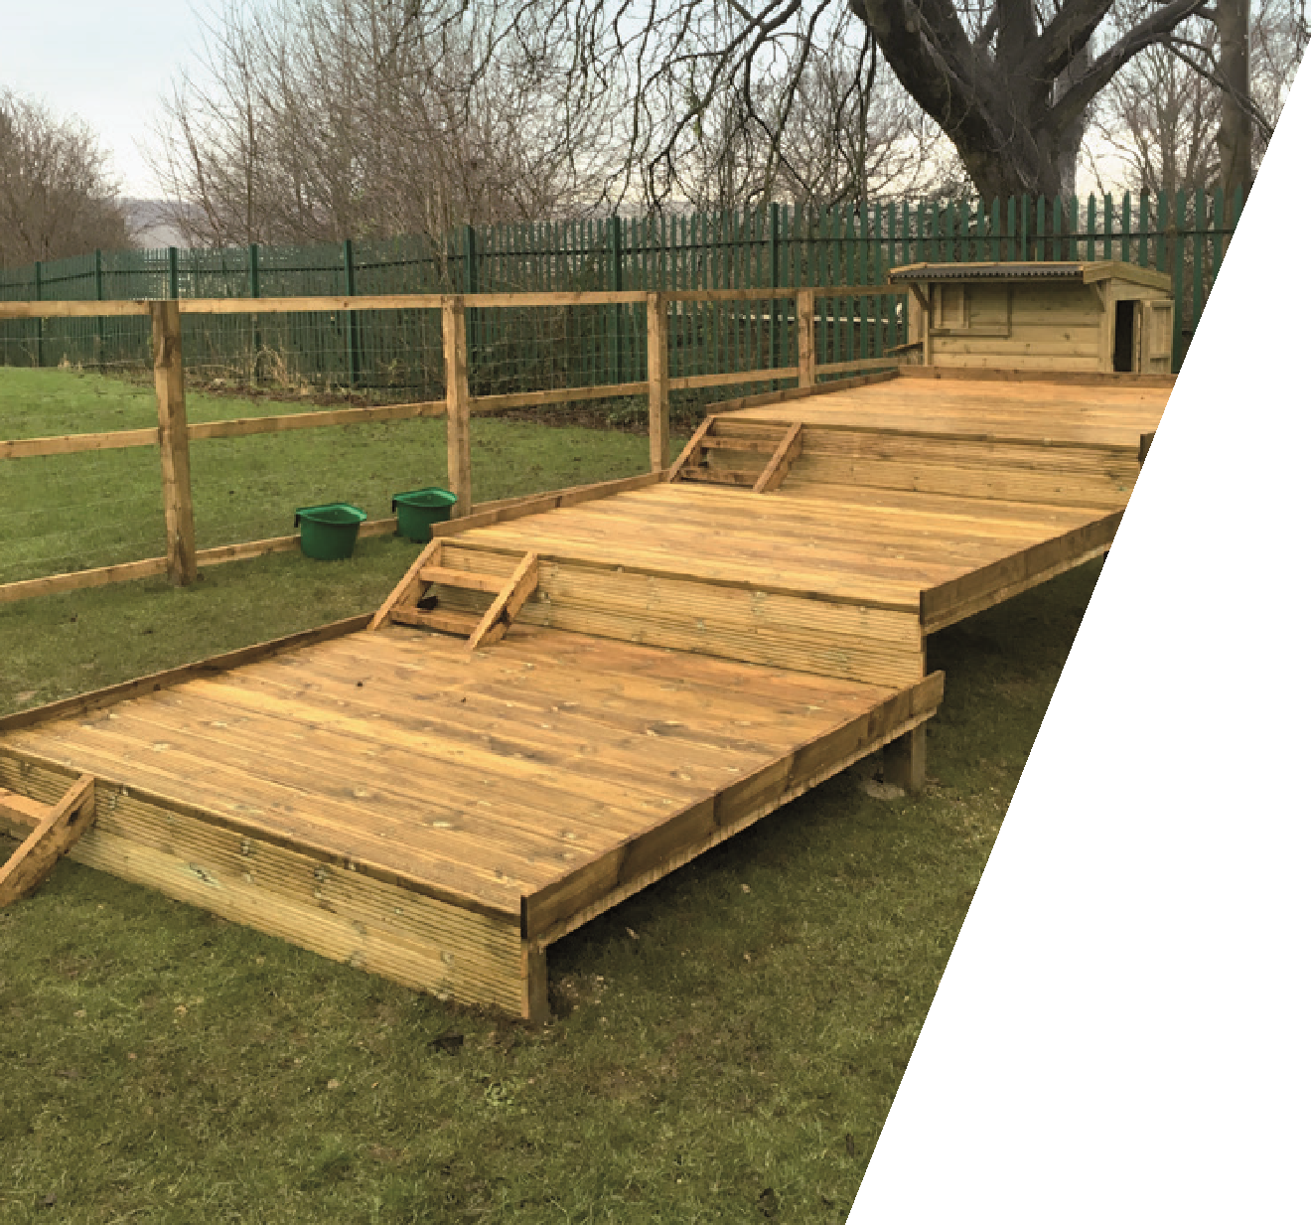
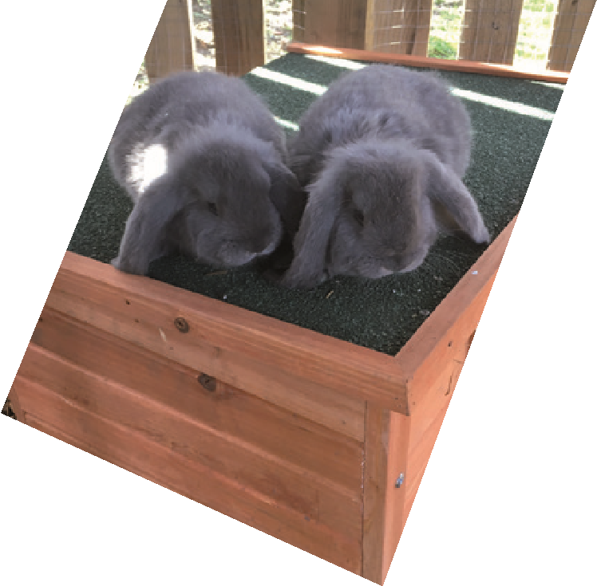
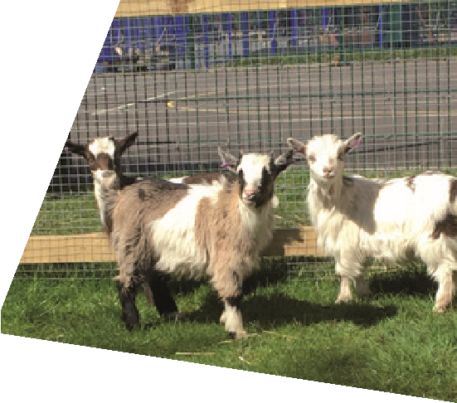
We research, design and build farms
for schools, tailor made to your
requirements and budget.
t. 01484 602534 www.geckops.co.uk
291
Wakefield Road, Lepton, Huddersfield HD8 0EL
01
484 602534
About us
Geckops are a well established School approved contractor. With a one stop shop approach that includes complete consultation on a range of building and environmental projects from conception to completion.
We work closely with schools to assist in improving the working environment for teachers and students alike. Our professional multi trade services also include architects and engineers, enabling us to design bespoke projects, moulded around individual school requirements.
Geckops have designed and built many bespoke farms for schools throughout the Yorkshire area and we are currently in the process of designing several new farms for schools locally.
For further information, please contact us on
01484 602534 or email us at info@geckops.co.uk

